**INTRO TO MAPPING WITH QGIS**

Robert Gebeloff

@gebeloffnyt

Dataharvest 2017

In the hierarchy of data journalism, there are spreadsheets. And database managers. And then there’s mapping ­­ another powerful way to analyze data. While working with data tables can tell you a lot about a dataset, plotting values on a map often reveals patterns that cannot be seen in tables of figures and charts.

Traditionally, the data journalism community has embraced mapping software called

Arcview, sold by ESRI, and many consider ESRI products to be the state­of­the­art.

But for small and non­profit news organizations, free, open­source software is a more practical solution, and in that sense, QGIS fits the bill. QGIS is also lauded because it supports both PCs and Macs.

QGIS is slightly more quirky and bug­prone than Arcview, but will almost always serve as an adequate substitute for the type of analytical mapping most data journalists wish to perform.

In this class, we will introduce you to mapping with QGIS ­­ demonstrating how to create maps with polygons, how to navigate the map with the software, and then how to join data for analysis into the map. We will also briefly touch on how to add “point” data to the map ­­data

that has geographic coordinates (latitude, longitude) attached.

But first, of course, you need to install the software… The Windows download page is here:

<https://www.qgis.org/en/site/forusers/download.html>

For this class,we’re going to skip the very recent new version and go to the stable previous version 2.14. If you’re on a newer system, you can download the 64­bit standalone installer, for older systems, you’ll need 32­bit.

The download tends to be slow, but the install is straightforward. You can install the practice datasets if you want, but we’re going to use our own data in this lesson.

For Mac users, the software is hosted by a 3rd party and can be downloaded here:

[http://www.kyngchaos.com/files/software/qgis/QGIS­2.14.10­1.dmg](http://www.kyngchaos.com/files/software/qgis/QGIS-2.14.10-1.dmg)

Note that because this isn’t “official” Mac software, you will probably need to right­click on the download and then select “Open” instead of simply double clicking on the download file. You will also have to install some complimentary packages included in the dmg ­ Gdal, NumPy, matplotlib ­­ before installing the main QGIS file.

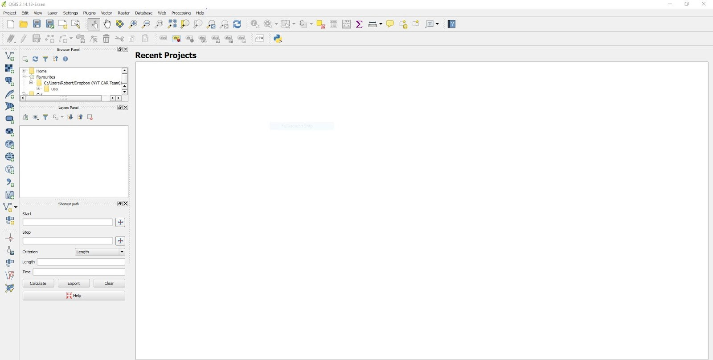

Like many programs, you can operate QGIS using the text menus on top, or by using the

buttons along the top and down the left side. The best way to become familiar with these options is to load a map file and explore it.

For this exercise, let’s visit London and see what we can find out about the city’s various wards. Download the main map file from here: <http://bit.ly/2pPsCy8>

Unzip the file, and then in QGIS, find the button near the top left that says “Add Vector Layer” when you hover over it. This will prompt you to find the map you just downloaded and unzipped. Within the unzipped directory, you want to find the “London­wards­2014_ESRI” directory, and then the file called “London_Ward_CityMerged.shp”. Note how a map file is made up of many components, but most of the time, it’s the .shp file that you’re looking for.

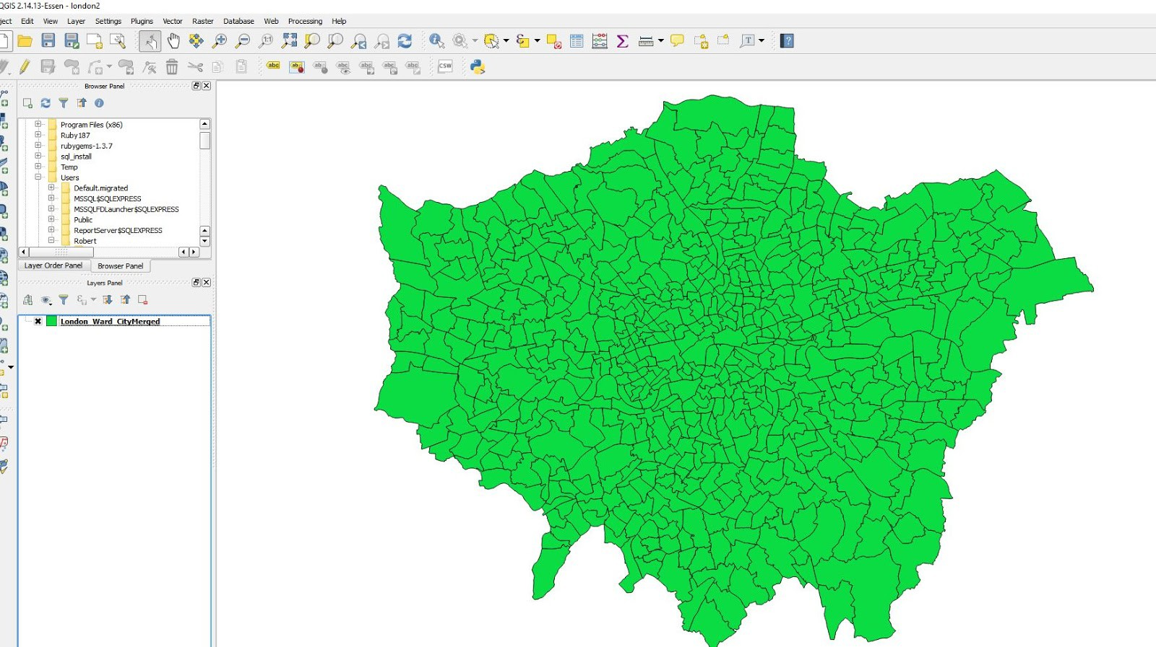

Before we get too far, let’s pause for a moment and think about the shape of the Earth.

Our computer screen is flat. But Earth is round. For our GIS program to work properly, we need to virtually bend our map to match this curvature. Why? Because much of what we do with mapping will involve spatial calculations performed by us by the software, and we need to have the software account for the bend.

To make matters more confusing, there are many different “projection” schemes that help adjust flat maps. Generally speaking, it’s a good practice to find out which projection is most commonly used by GIS experts in the region you are mapping. (You will also notice that if you don’t pick a projection, QGIS will adjust your map on the fly, which is sometimes ok for just looking at the map but will foil your spatial calculations.)

A bit of Googling reveals that a commonly used projection for the UK is called T[he British National Grid](http://spatialreference.org/ref/epsg/27700/), so we’ll go with that.

To convert our map, let’s right click on it and use the Save As menu.

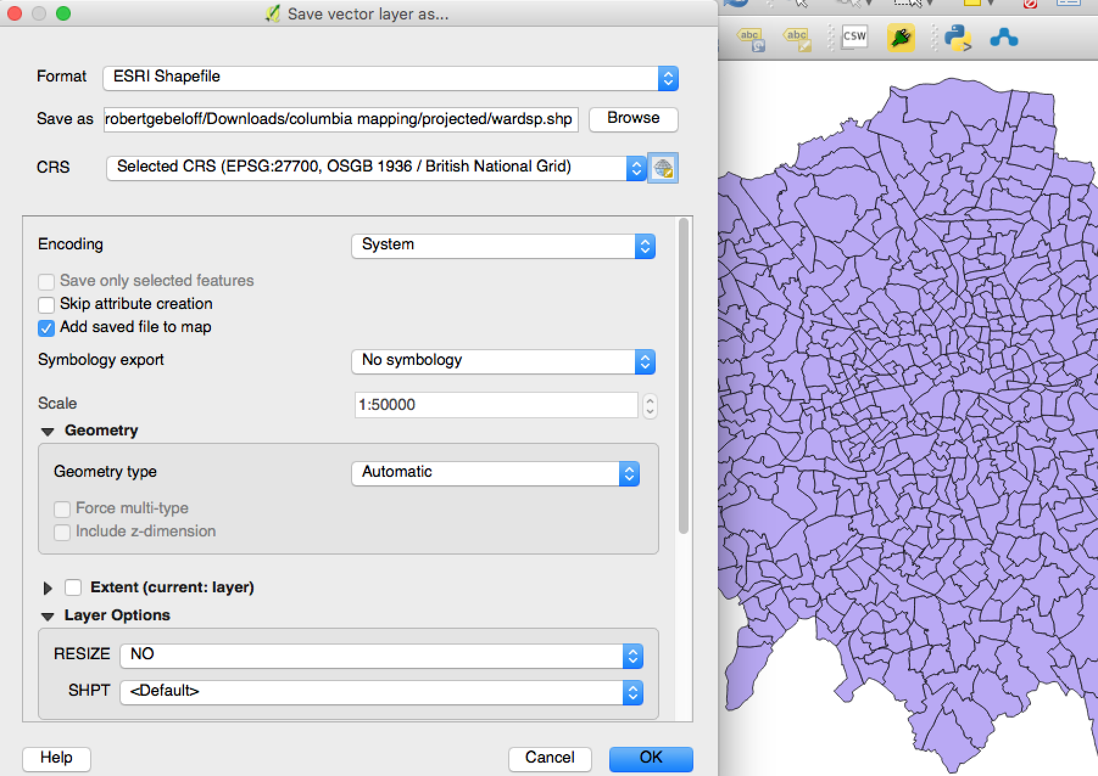

I liked to created a folder called “projected” in my project folder. I can then find the British National Grid in the CRS box. Once you save this, it will add the projected file to your map. You can right-click and remove the original file. You should also set the map view to our projection by clicking on the “Render” button on the bottom right.

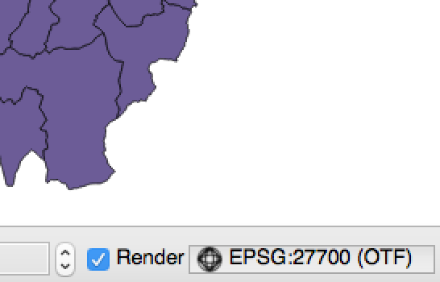

We can get some more decorative map components from the free Open Street Map project. The entire set of free files is here: <http://bit.ly/2pvCmQa>, but for now, I’ve pulled out one component that we’ll use, the waterways, which you can grab from here:

http://bit.ly/2FtVR1D

Unzip the waterway file and add both shape files ­­ one is for major waterways, one includes the more minor streams. Then save both projected to the British National Grid as above.

We can make these map layers look like water by changing the color. Double­click on the layer name, and under the style menu, choose the color for water:

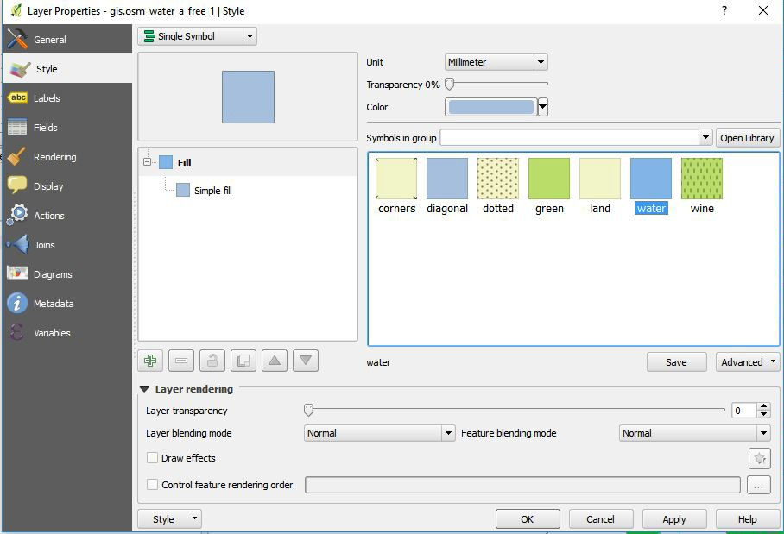

Let’s also for now, to show the contrast, change the color of our Wards to black. Because the border of the wards is also black, this will really create a contrast between land and water:

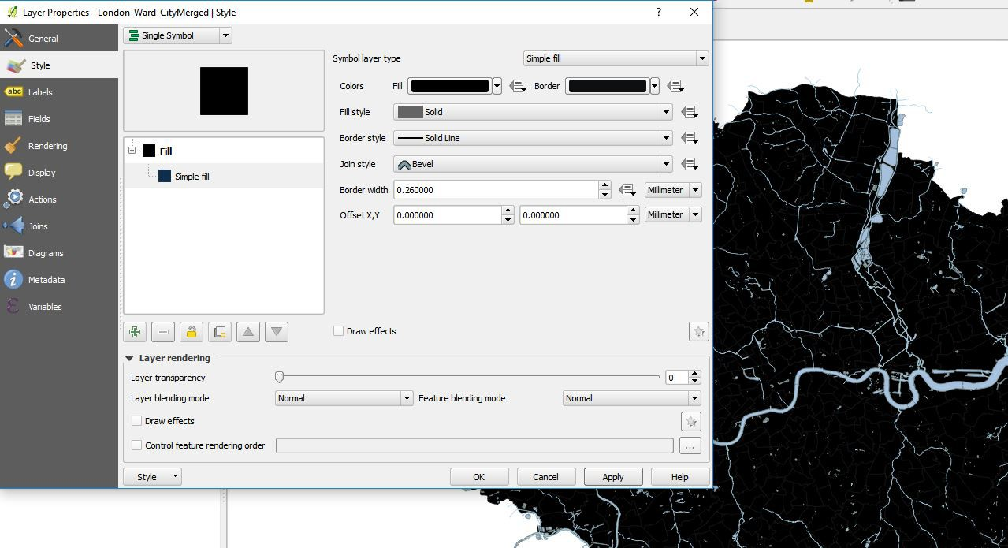

Can we do anything more useful with the style menu? Double click on wards again and change the drop­down menu to categorized, pick the borough column and click the “Classify” button, then hit apply to preview the changes and ok to finish:

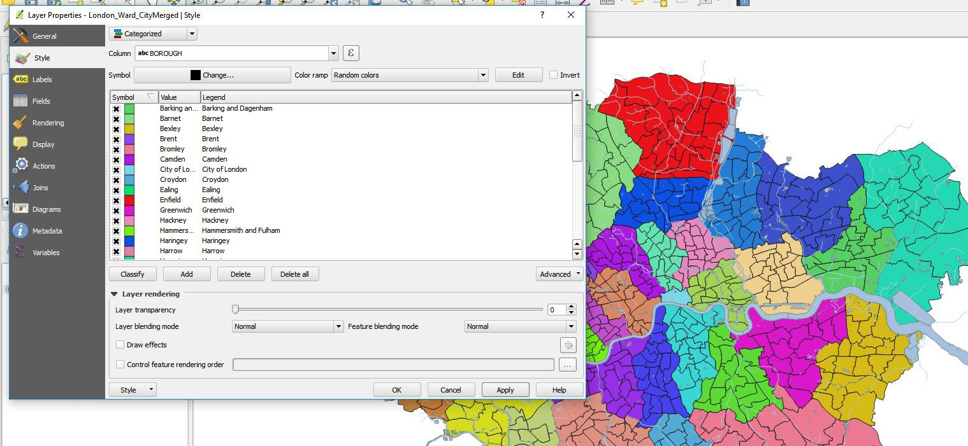

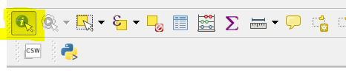A quick overview of some tools we can use to examine the map: The Info Button:

The Zoom Buttons: 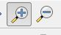 The Pan Button: 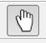 :

Zoom to Full Extent: 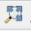

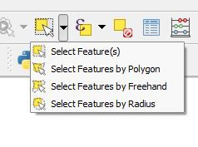The Select Buttons:

Selecting data is an important part of GIS analysis because you often want to subset the data you are working with.

Let’s take these one at a time.

Select by Polygon allows you to draw a polygon on the map and right click to select all wards that touch the shape you drew.

Select by Freehand allows you to do the same but without the right click.

Select by Radius allows you to draw a circle and select all Wards within the circle.

These are mildly useful, but the more useful button is in the middle, Select by Expression:

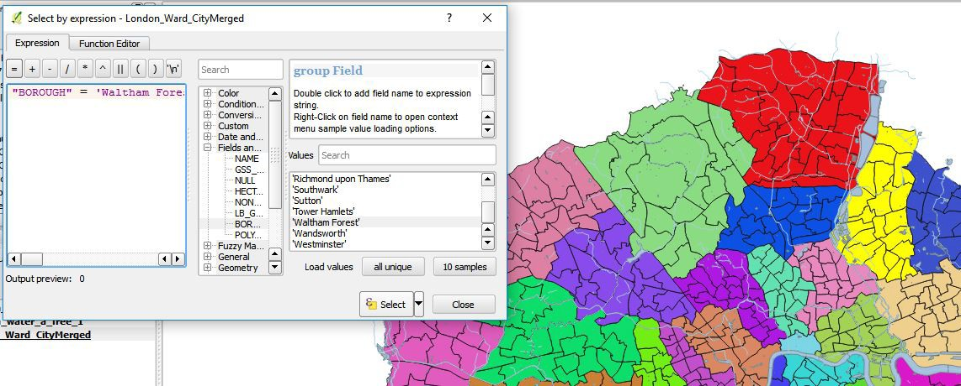

To clear the selection, click the deselect button  from the top of the screen:

How else can we style this map? Let’s change the style from Categorized to Graduated, and pick Hectares, and for mode, pick Quantile. To keep our contrast going, change the color ramp to Reds, and then hit apply:

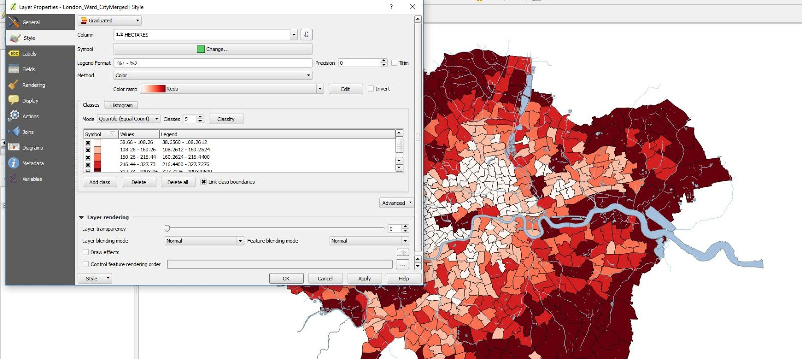

What happened here? QGIS examined the hectares column and created five equally sized groups. It figured out that to be in the bottom fifth, a ward would have to be between 38.66 and

108.26 hectares, up until the largest group, for which a ward would have to be greater than

327.73.

Pause here for a second and explore the other classification systems built into QGIS. For example, what if you change the number of classes? Or use “Pretty Breaks”.

What’s important to note here is that the decision you make here is a form of journalistic decision­making that is akin to many other reporting tasks: Who do you interview for a story? What questions do you ask? What quotes do you use in the story? In other words, when you create a color­coded “choropleth” map, you need to choose your classification rules wisely and fairly based on the underlying data.

Let’s put this thought to use by bringing in some more meaningful data, The [London Data Store](https://data.london.gov.uk/) has some rich data summarized at the ward level. Let’s take a look at a file they provide called “ward profiles” ­­ I’ve created a local copy for our class - http://bit.ly/2CjIlPo

Let’s open this up and see what’s inside:

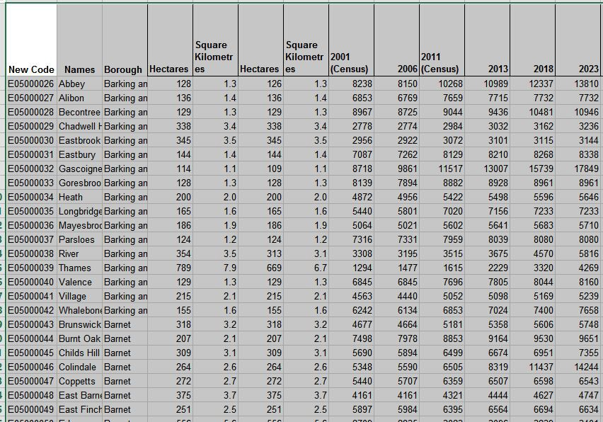

What we’re going to do is “join” this data to the data in our map. And just like any database join, we need to have something in common between the two datasets. The column labeled “new code” looks promising. Let’s see if we have that in our map. Click the “Open Attribute Table” button in QGIS 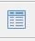

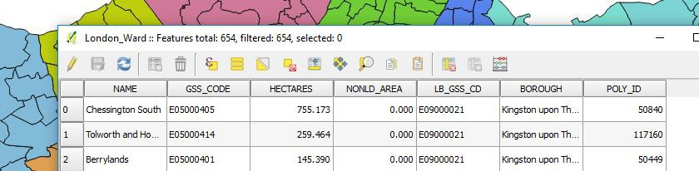

Voila ­­ it looks like we can join the spreadsheet’s “new code” to the map’s “GSS_CODE”. Before we can do that, there’s one other step. We need to save the spreadsheet as a csv file, a

generic data storage format that QGIS can read. We also need to clean the file up and remove

any extraneous text ­­ as we’ll see in a moment, sometimes QGIS has trouble determining whether a CSV column is text or numeric, and in this case, we want our data to be numeric. In Excel, scroll to the bottom of the file to make sure there is no extraneous text. (If there is delete it ­­ we only want rows and columns of data with one row for headers.)

Then click on File, Save As, and choose csv as the format. (**NOTE**: On a Mac, you must choose Windows CSV as the format because Excel creates CSVs with different line endings on the two systems.) Excel will prompt you a couple of times­ click OK, then Yes, then close the file in Excel, and click “Don’t Save” ­­ we’ve saved it the way we want to already.

Now, in QGIS, to add the data file, click on the add CSV button: 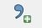

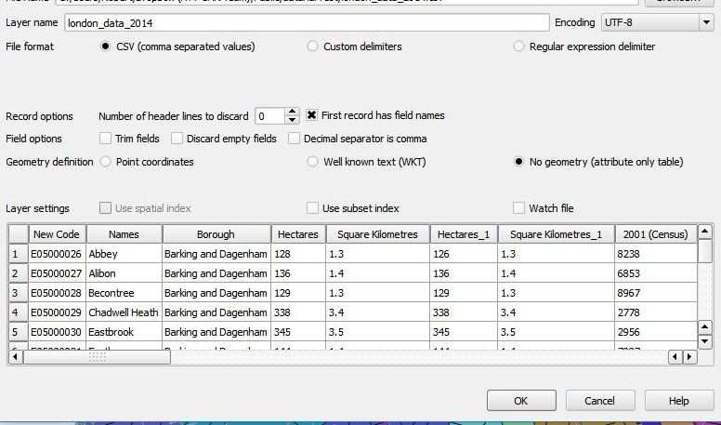

Make sure “First record has field names” is checked, and under geometry, select “no geometry”, and then click ok. The data file is added to our list of layers.

Double­click the “London_ward” listing to get back to its attributes, and find the “Joins” menu and hit the plus sign to set up a new join:

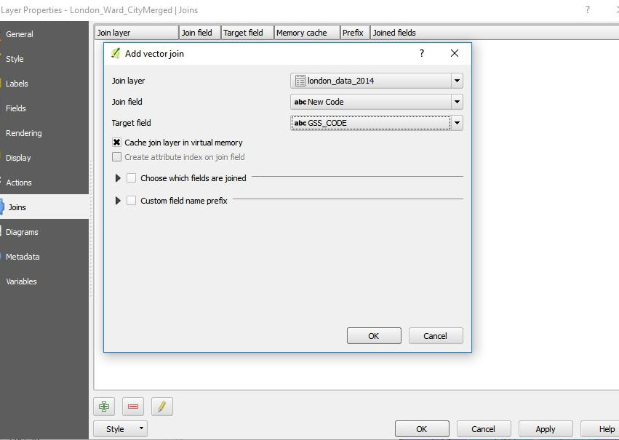

Pick the ward­profiles as the join layer, and tell QGIS you want to join “New code” to the target

“GSS_Code.” Then click Ok.

Now if we go back to style the Wards layer, all of the numeric fields from london_data_2014 will be available to us. Let’s pick “Not Born in the UK” as our column, yellow­orange­red as our color ramp, and natural breaks for our buckets:

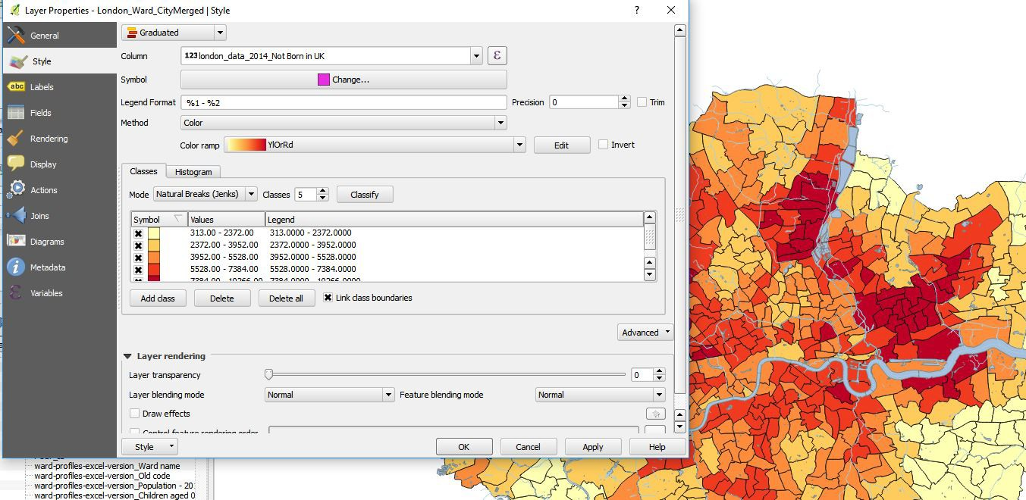

So now we have something interesting ­­ a map that shows us the foreign­born population of the

UK. But can anybody think of a way to make this map more accurate and meaningful?

Yes, by making our map based on the raw population, we’re in danger of simply showing population density. What if there are more foreign­born people in some of the wards simply because there are more people overall in the wards? What we really need to do is calculate the PERCENTAGE of the population that is foreign­born, and for this, we can use the QGIS field calculator.

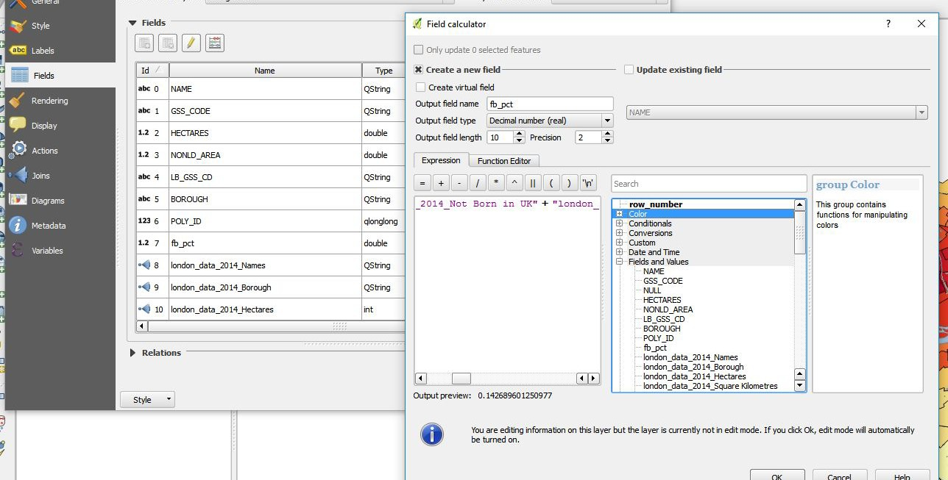

Under the London Ward fields menu, click on the abacus icon to create a new field. Let’s call the new field fb_pct and because we’re going to be calculating a percentage, let’s give it a field type of decimal, with a precision of 2 (if we don’t specify this, QGIS will round it up to a whole

number, which we do not want).

We’’ll use the QGIS GUI menu to create our formula:

"london_data_2014_Not Born in UK" /( "london_data_2014_Not Born in UK" + "london_data_2014_Born in UK" )

We hit ok, then click on the pencil to get out of editing mode and save our changes. We can now make a map based on our new field, fb_pct:

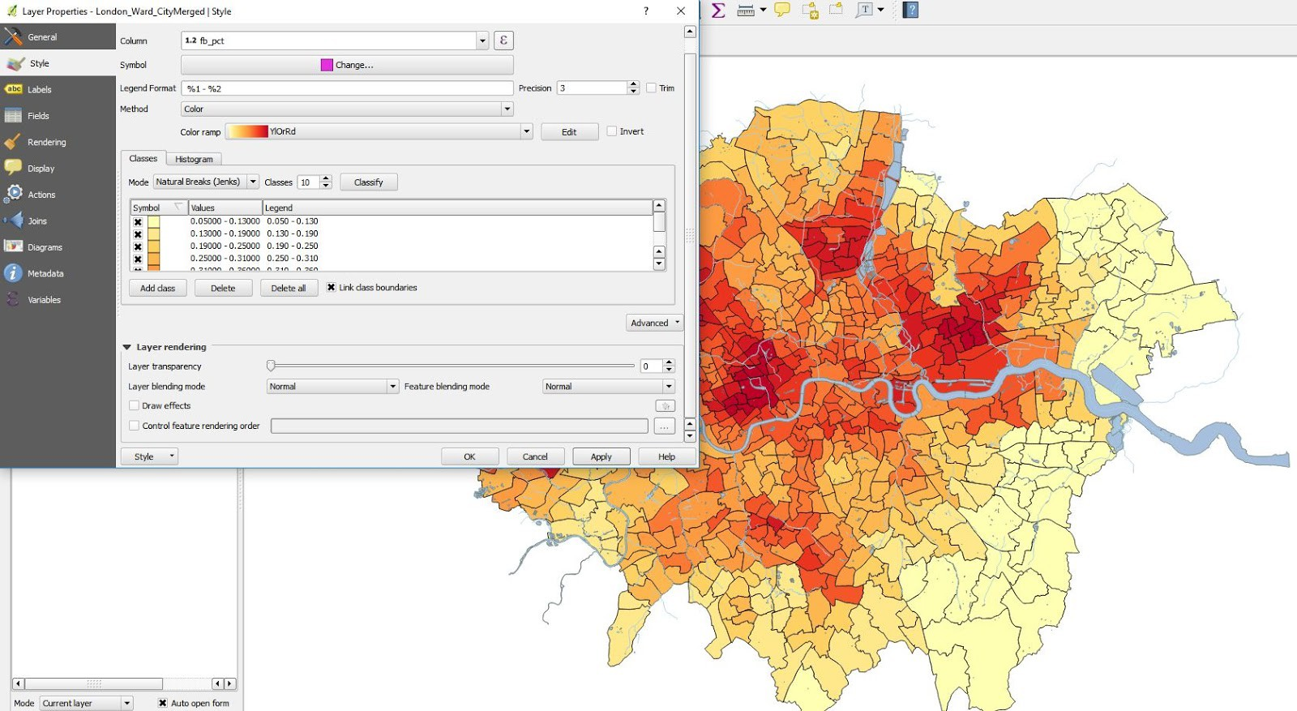

One other cool thing we can do. QGIS is tied to a lot of open source resources. If we want to incorporate a Google Street map, or one of several other open source maps, it’s easy.

First, we should make our map more transparent so we can see the street map. On the wardsp style menu, set the transparency to 60 percent.

Then, under Web/Open Layers Plugin, pick Google Streets. On your Layers Panel, you can then drag Google Streets under your map and zoom in – you can now see exactly where these pockets of immigration are.

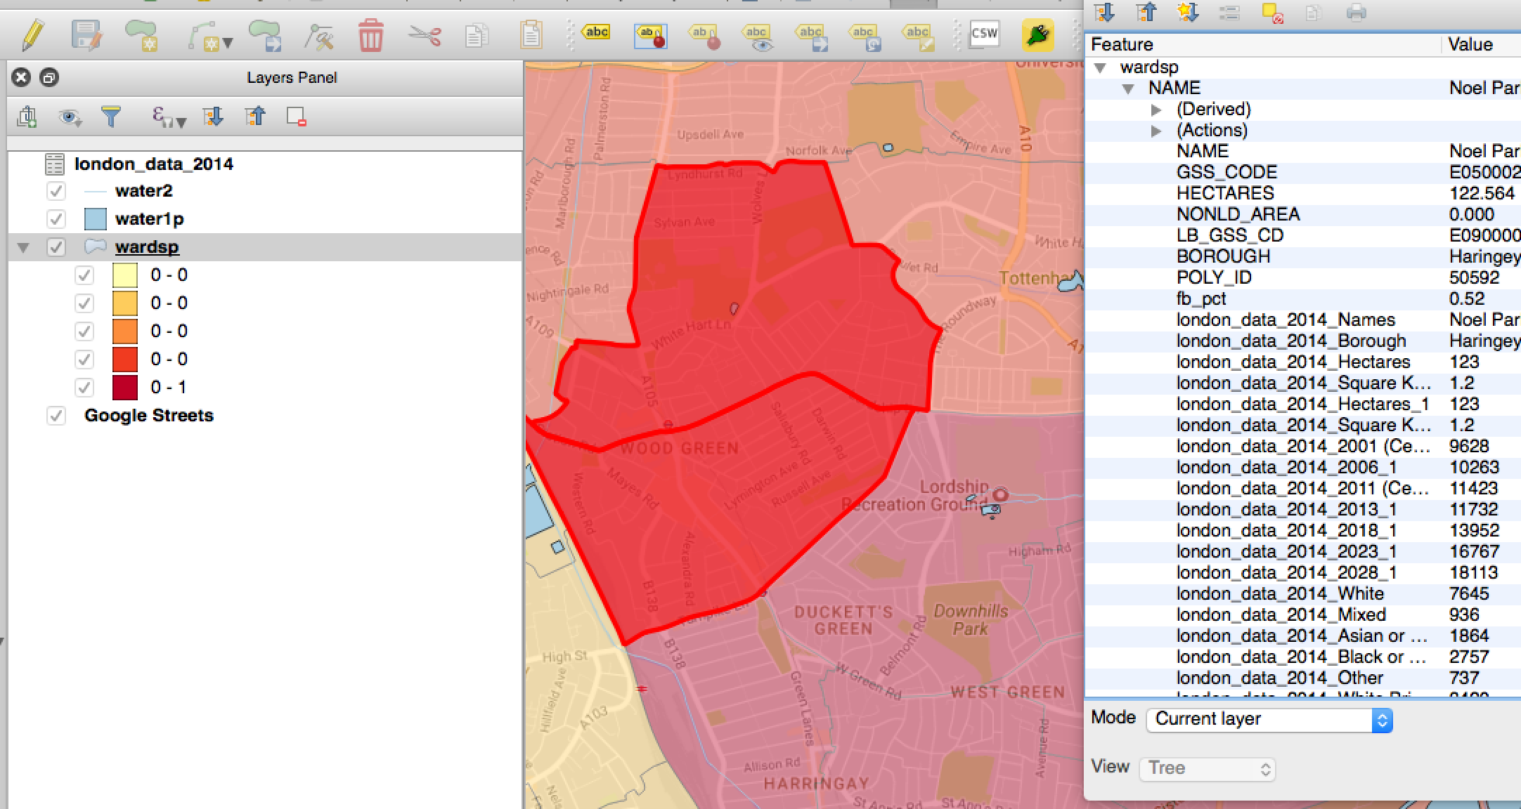

This brings us to the end of Part I of our lesson. If there is still more time, think of other variables that would make for a good map and have a go at it.

PART II ­­ THE ART OF THE SPATIAL JOIN

So far, we’ve explored the basics of mapping with QGIS and worked with polygon layers. We’ve joined summary data about London wards to a map of London wards and created a “choropleth” style map to show some patterns.

In this lesson, we work work with “point” data ­­ dots on the map representing a specific place or an incident that occurred at the place. We will show you how to find patterns in your points, how to convert raw GIS coordinates into QGIS points, and most interesting of all, show you how you can marry points to polygons via a “spatial join” and take your analysis to a new level.

So to review what we have so far, you should have a QGIS project containing a map of wards in the greater London area. To this let’s add a layer containing places of worship in the Greater London Area, which I obtained from Open Streetmap but have posted here:

[http://bit.ly/2COa4U9.](http://bit.ly/2qjsYgz) Once you download and unzip the file, you can add the places of worship as a layer just like you would a polygon map:

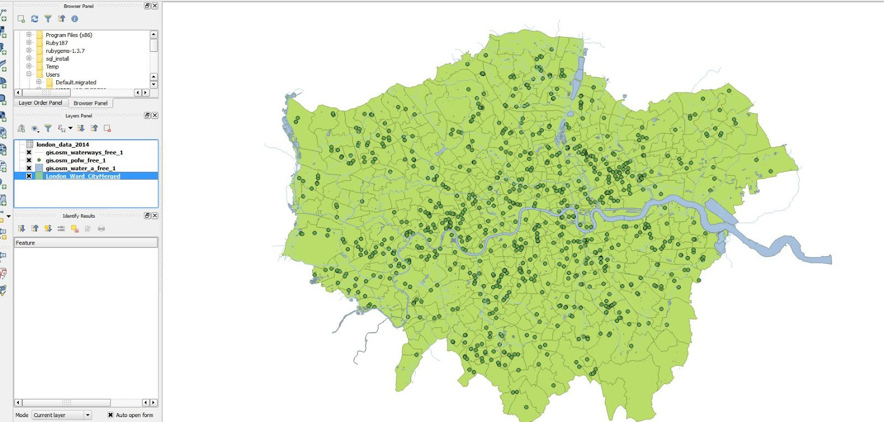

While QGIS auto-adjusts this file to match your map’s projection, let’s reproject this layer to match the British National Grid.

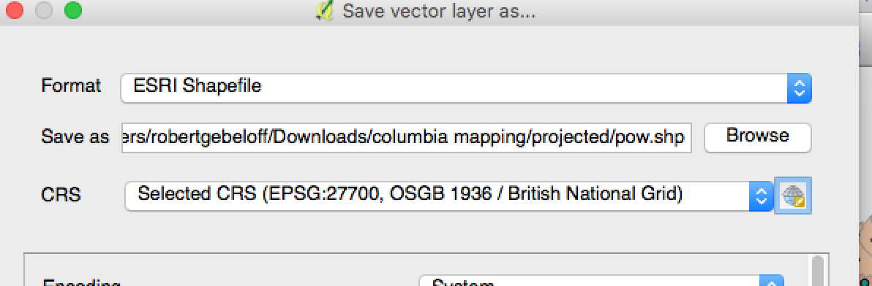

When you’re done, you can remove the unprojected layer.

And just like a polygon map, there are certain simple analytical looks you can create for the data. For example, let’s color the points by category:

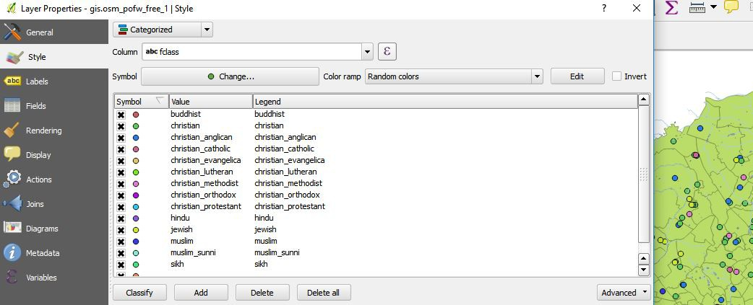

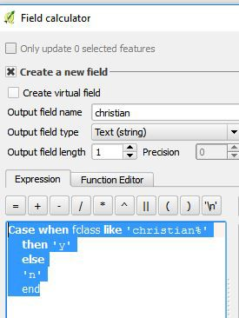There are a lot of denominations. Perhaps we want to collapse the categories into two groups

­­ Christian denominations and non­Christian. We can do that with the field calculator. Click on Fields, then the abacus, and then enter a new field name called christian, we’ll make it text with a length of 1 and create it with a classic SQL Case..when statement:

CASE WHEN fclass LIKE 'christian%'

THEN 'Y'

ELSE 'N'

END

Once we execute it , we’ll get a new field in our point map file that we can use to classify the points by two groups:

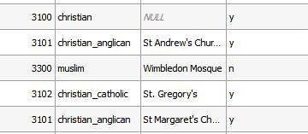

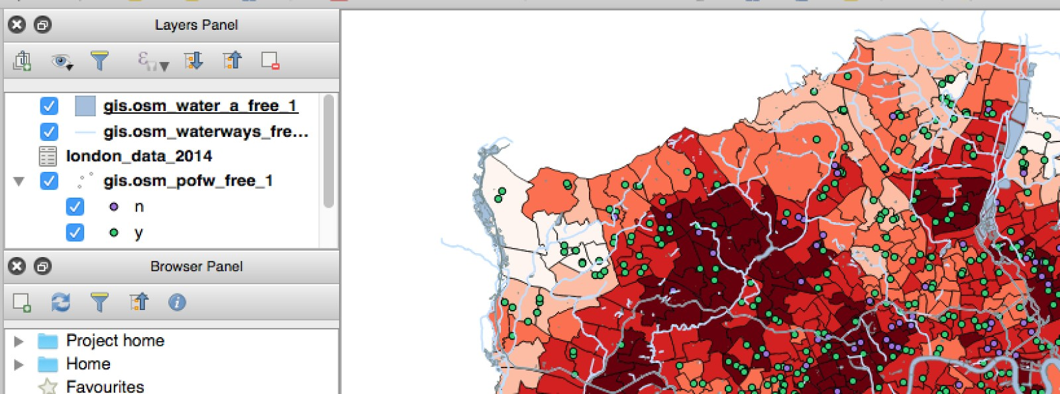

Another popular visualization that can be done with point data is a heat map. We can convert the points to visual “blobs” representing the density of the points ­­ in this case, the visualization would show where churches are most concentrated.

To make the heat map pop, let’s first change the ward map to a single symbol, preferably a light color. Then on the place of worship theme, choose Heatmap, pick the red color ramp, and set the layer transparency to 33.

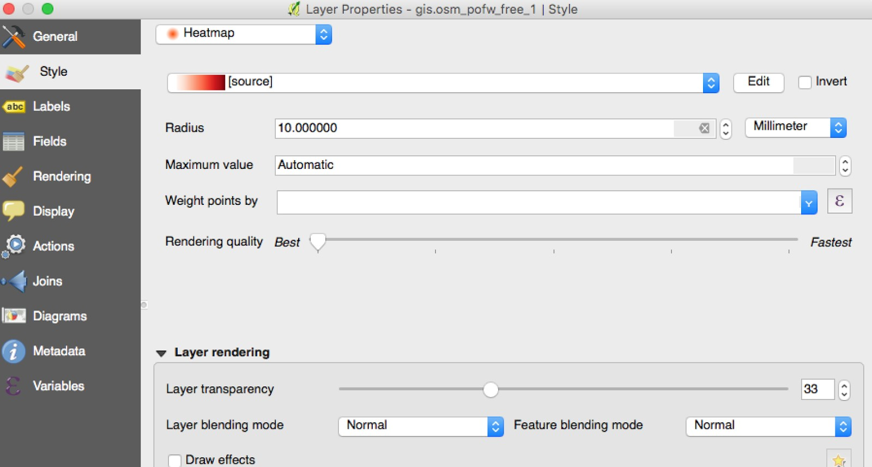

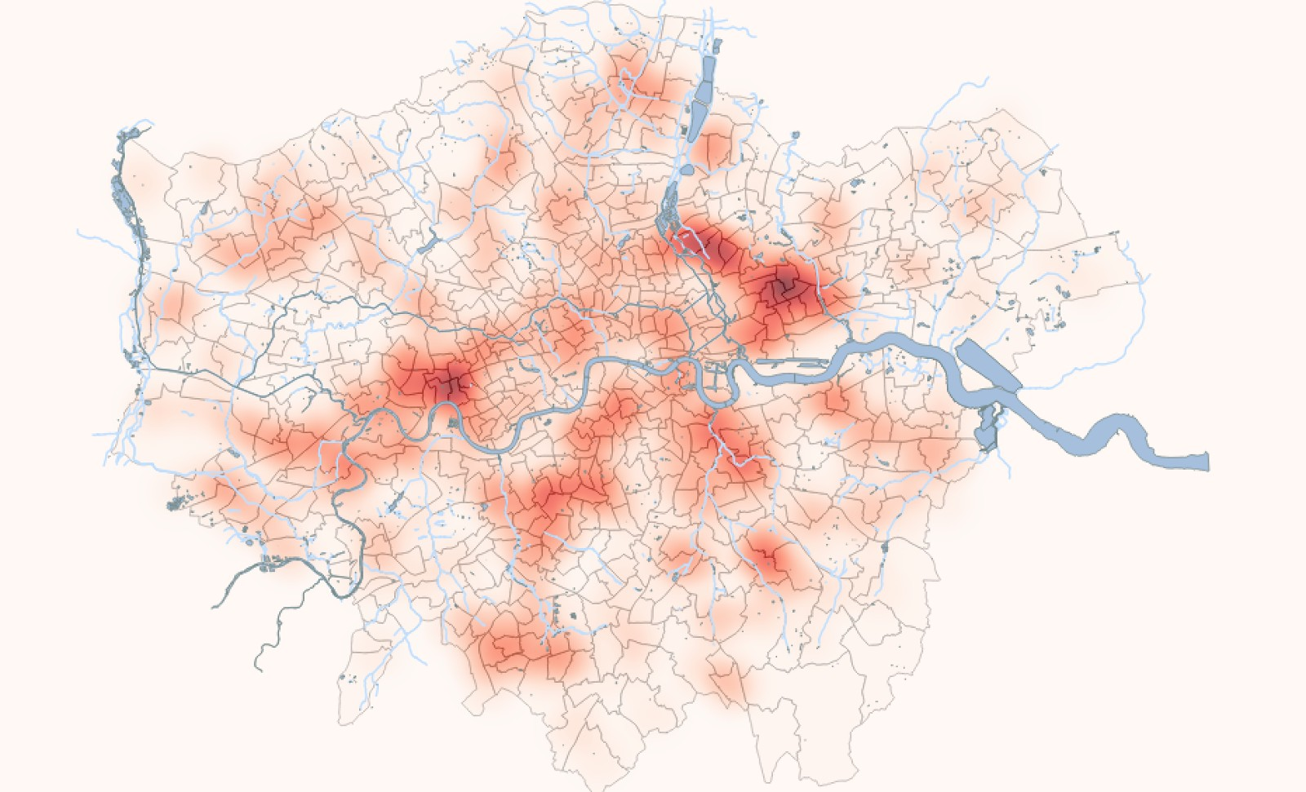

Very cool to look at. You can play around with the parameters and see how your visualization changes. But there are two problems with heat maps: 1) What happens at the edges of our map? Because we are missing data from churches outside of greater London, we’re underestimating the edges and 2) How easy would this be to explain to our readers?

Another approach is to do a “spatial join” ­­ to assign each point on our map to the polygon it sits inside of. This approach will yield for us a count of houses of worship for every ward in greater London.

Click on Vector/Analysis Tools/Points in Polygon:

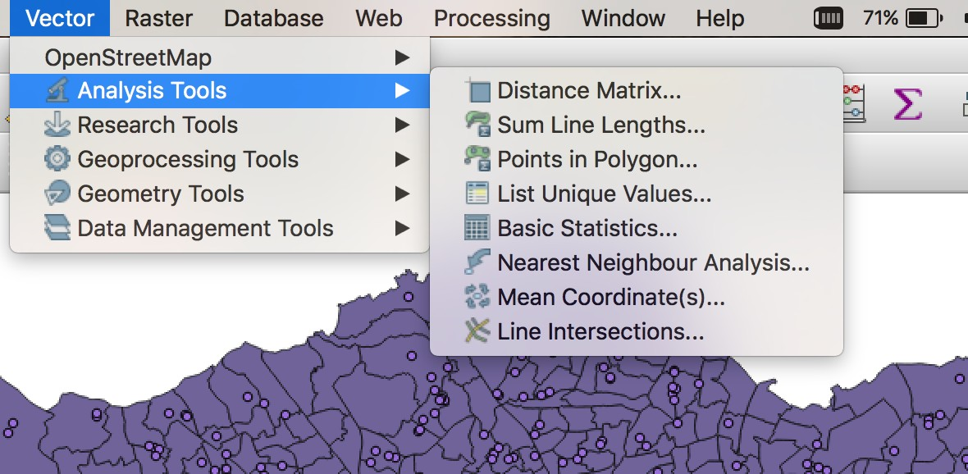

From here a menu pops us that allows us to set the parameters for our spatial join:

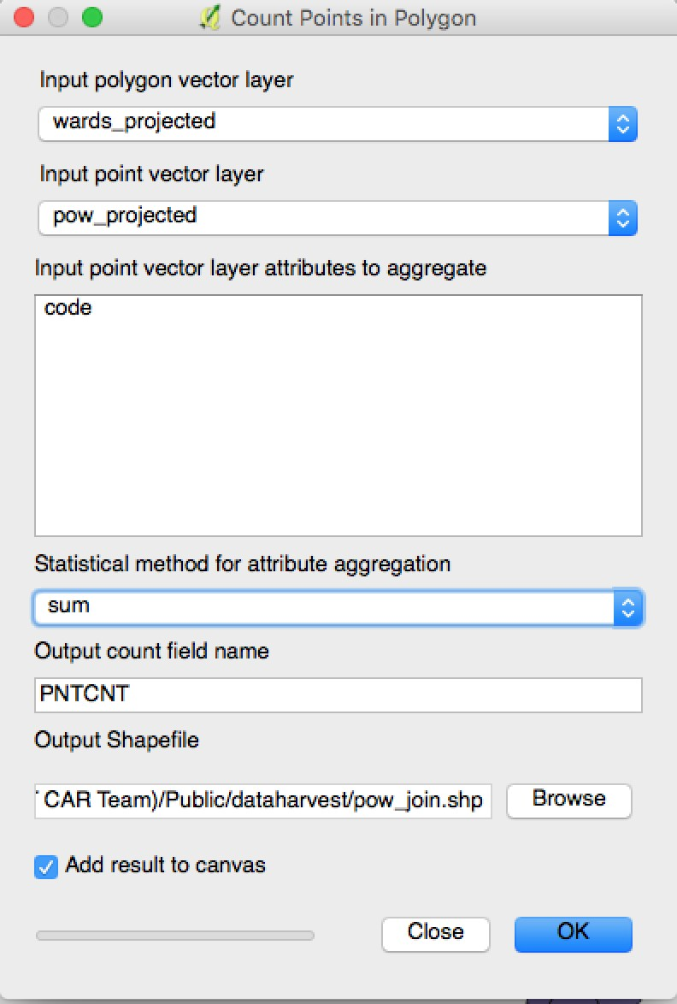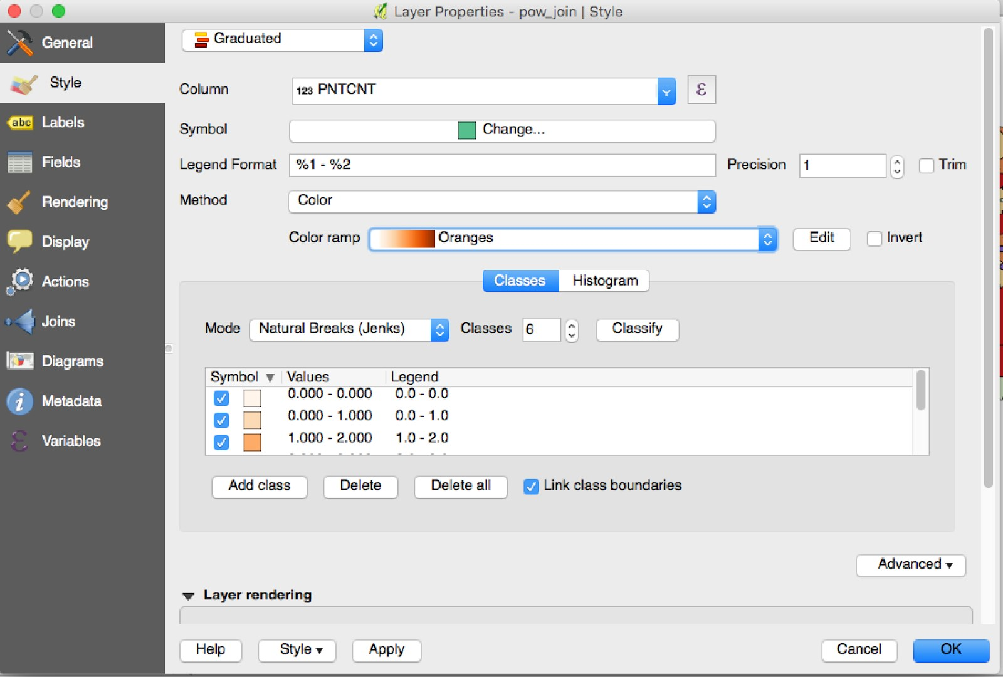

Now we can make a choropleth based on the values…

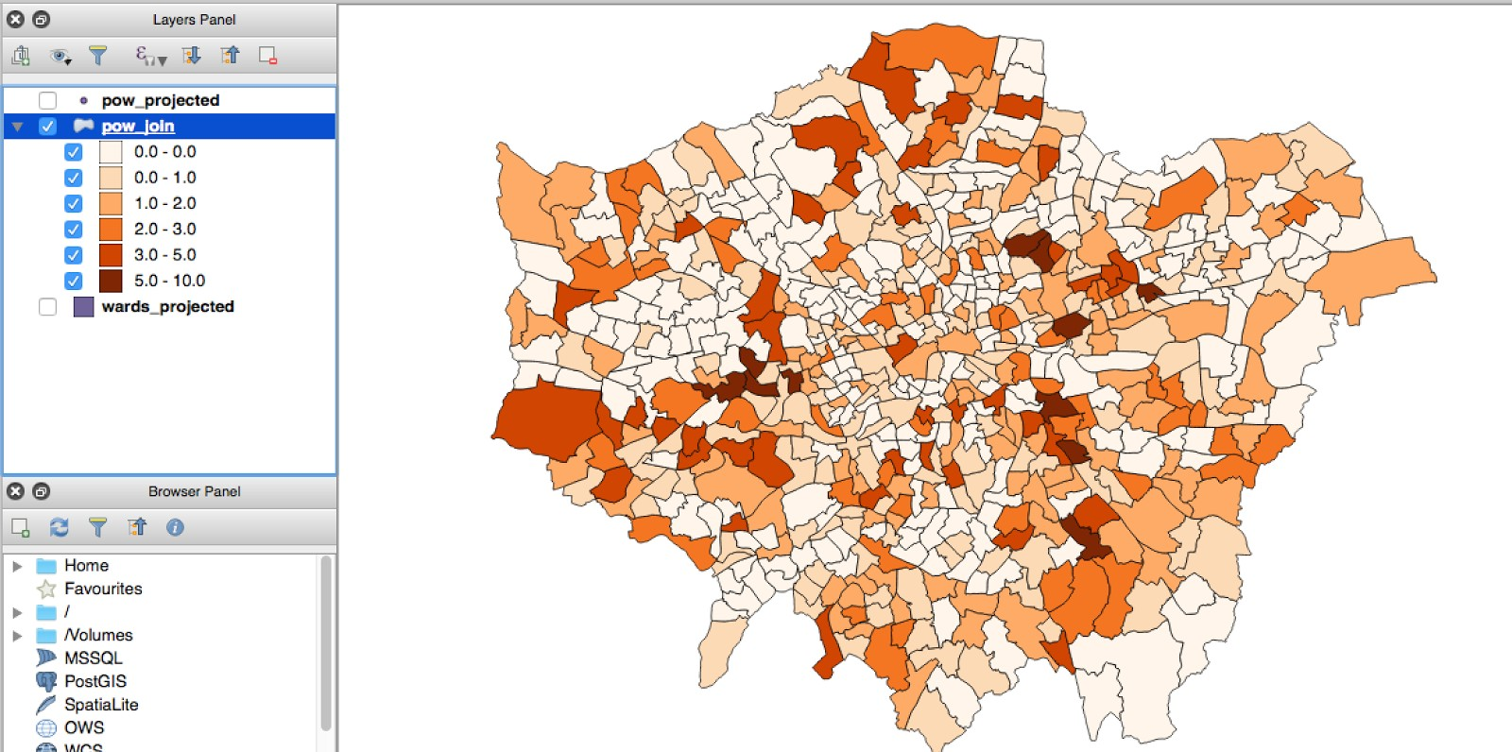

Conversely, we could have added the polygon’s attributes to the points. Let’s say you wanted to quickly make a list of places of worship in Bexley. To do this, you’d look under Processing | Toolbox | Vector Point Tools:

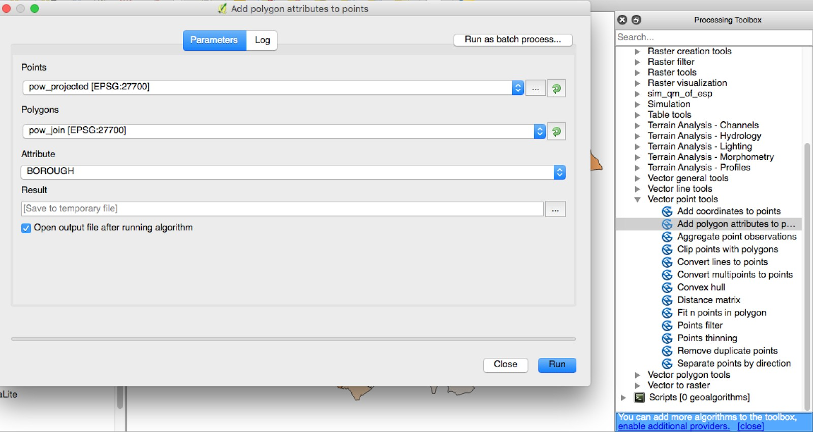

Let’s close with one more example that will combine a number of skills and hopefully bring this all home.

Often, we run into data on the Web that we can view, but that we wish to analyze further. Sometimes the data provider will give us a download link, but sometimes, the data is on the Web in a format in a display only format.

Let’s say we were working on a story about the density of pubs in London.

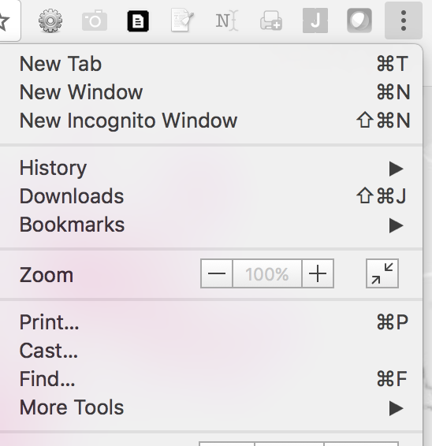

Tough job, but somebody’s got to do it.

The government has a map identifying the location of each place, which is designed for users to look up pubs one at a time.

But we want to do an analysis. By launching Chrome developer tools, we can find the underlying data for this map and bring it into our project

.

By clicking on the Network section, reloading, and sorting by size, we see a list of all of the underlying elements on the page, including a json query that produces the underlying data for the map.

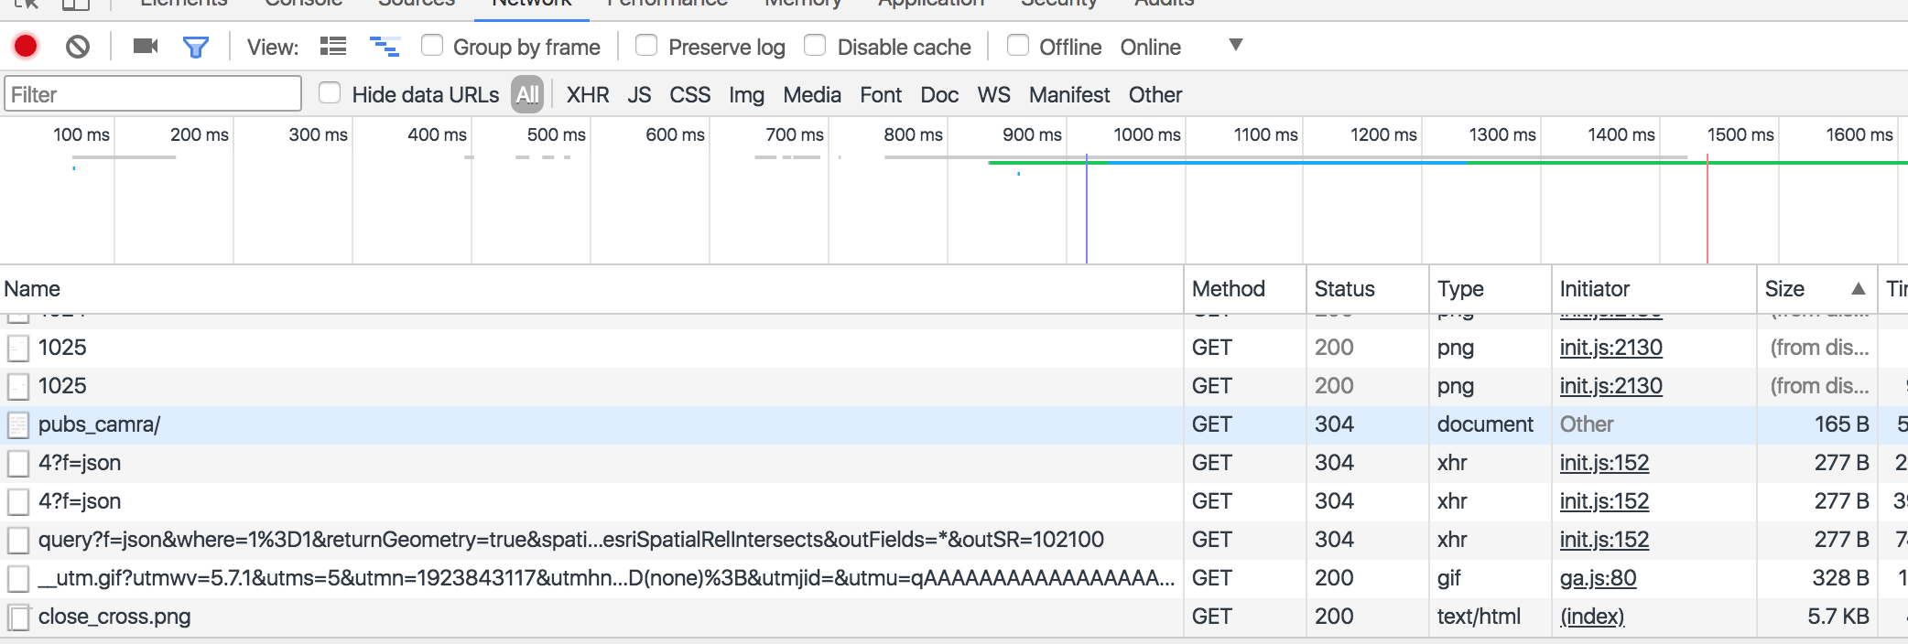

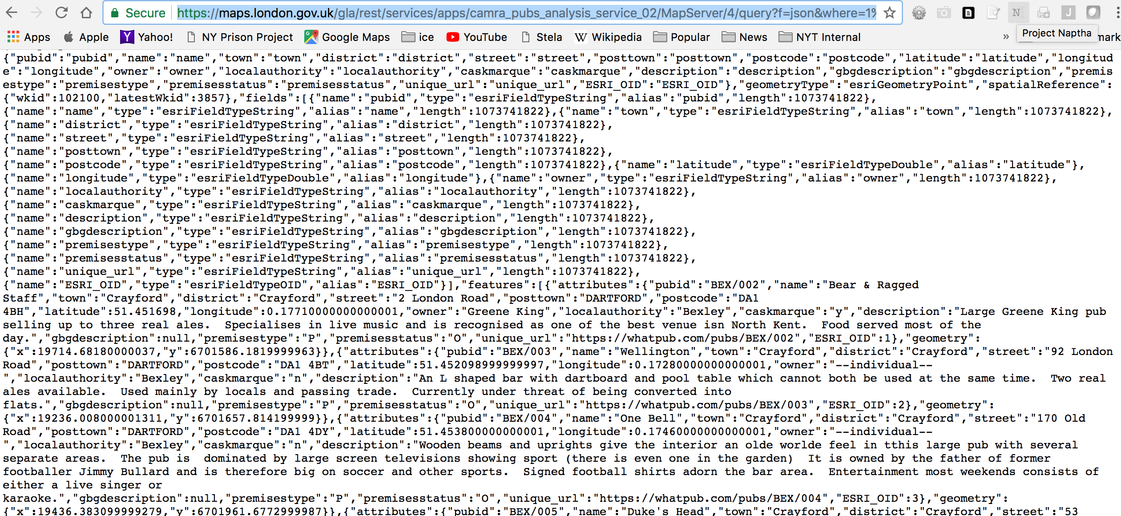

That looks like all the data we’d want. But it also looks like a big mess. Fortunately, the world is filled with conversion tools. And this one turns our messy json into a highly useable csv file -- <https://sqlify.io/convert/json/to/csv>.

We can download the results file now and import it into our London project.

I will tell QGIS to use the latitude and longitude fields in our data.

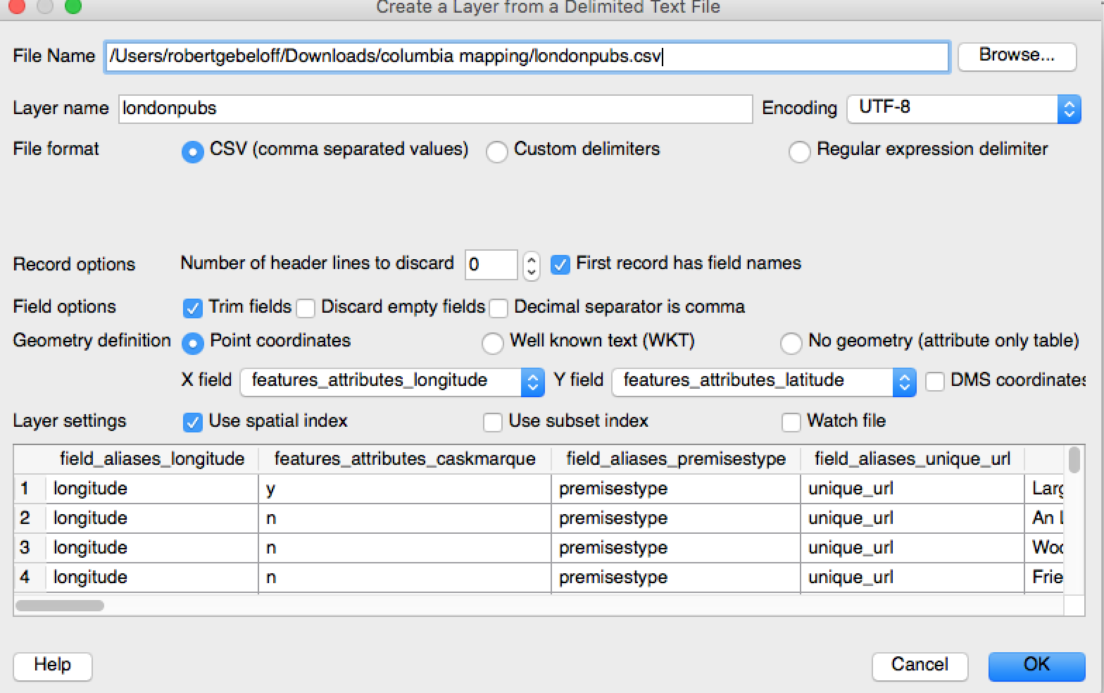

I can then save a projected version – British National Grid – into our projected folder.

Now the fun part – Heatmap!

Well, that didn’t go so well. It basically showed us there are so many pubs in Central London that the density outside the central city doesn’t register.

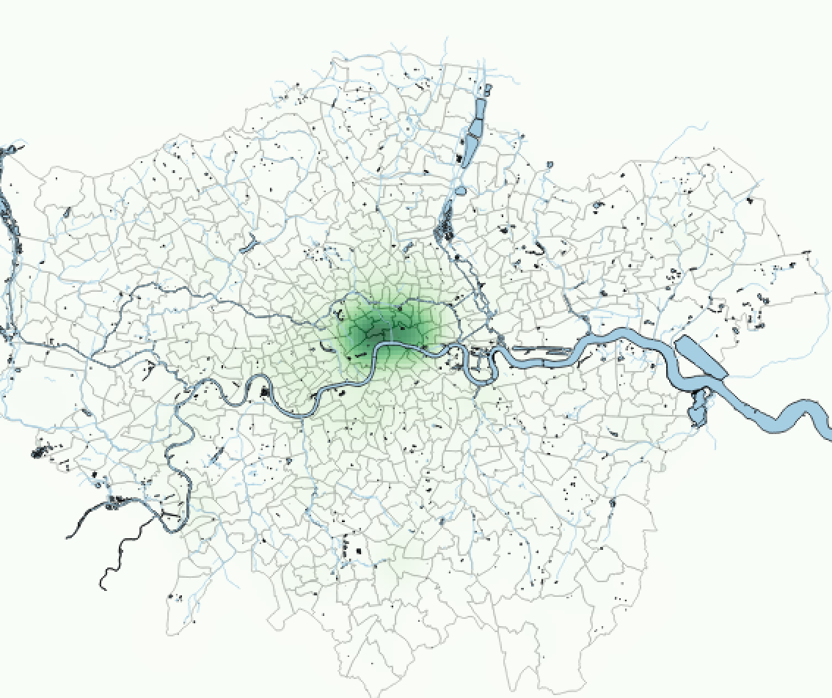

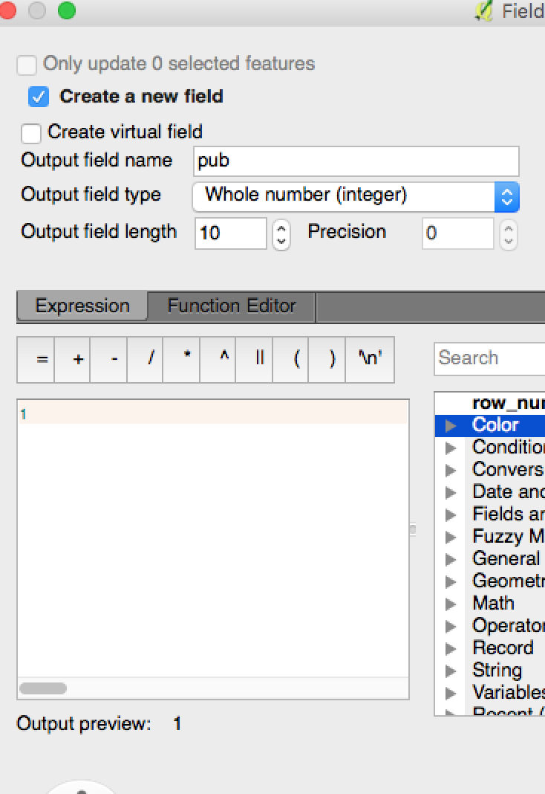Let’s try Points in Polygons. One thing we need to do is give this algorithm something to count, so I’m going to create new field in pubs called pub and assign it the value of 1.

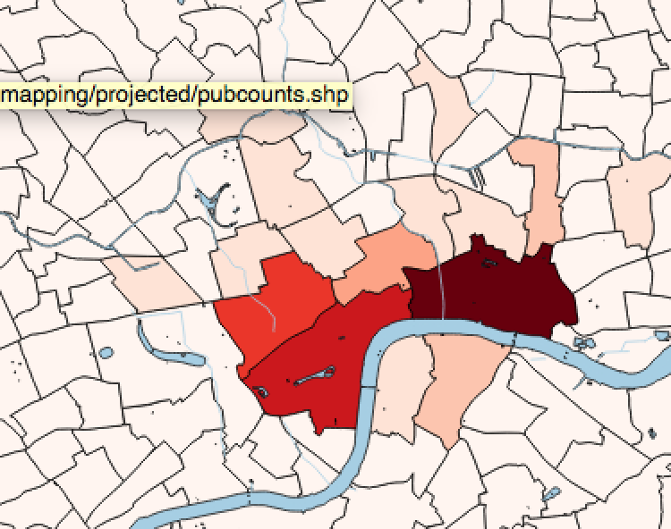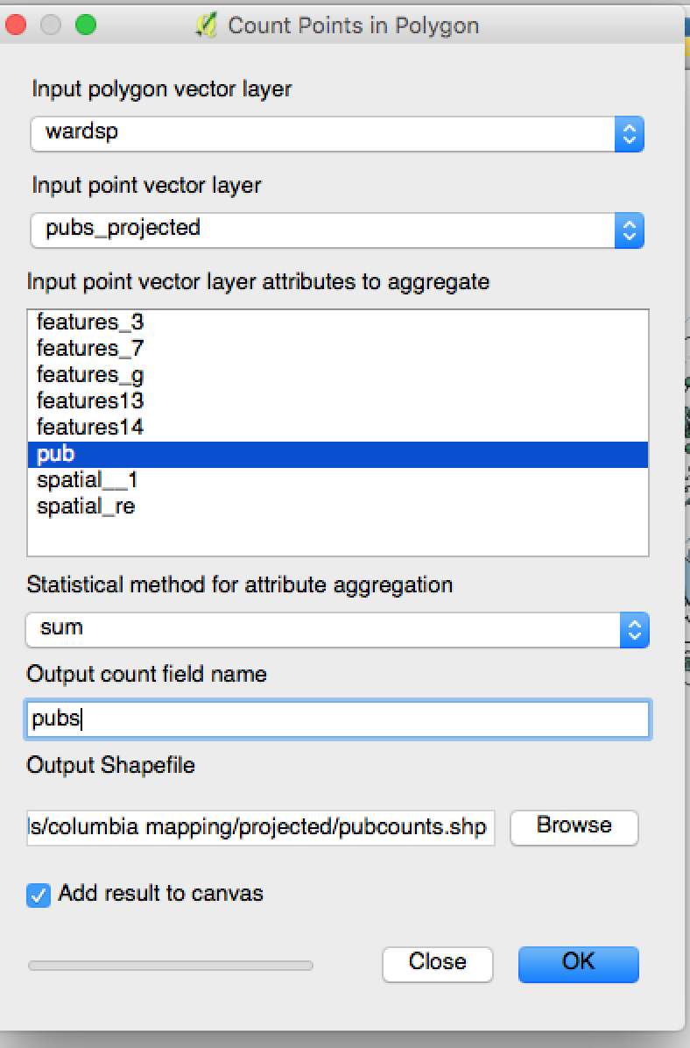

It appears via a thematic map that the East End has it over the West.

But we should try one more thing. The number of pubs is nice to know, but what if we calculated the number of pubs per 1000 Hectares. I do that by creating a new field, of the real type, and using this formula:

(pubs/hectares)*1000

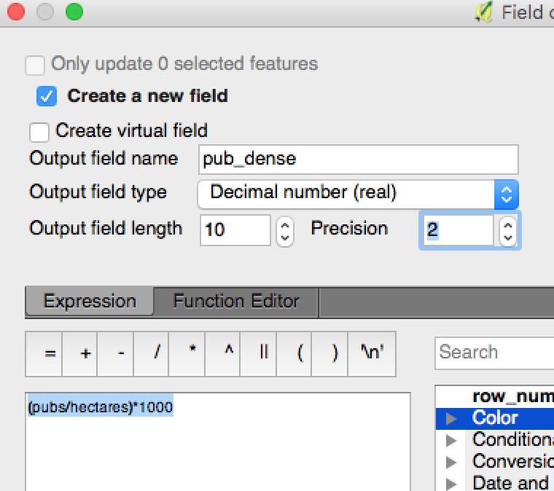Now we get a more nuanced picture…

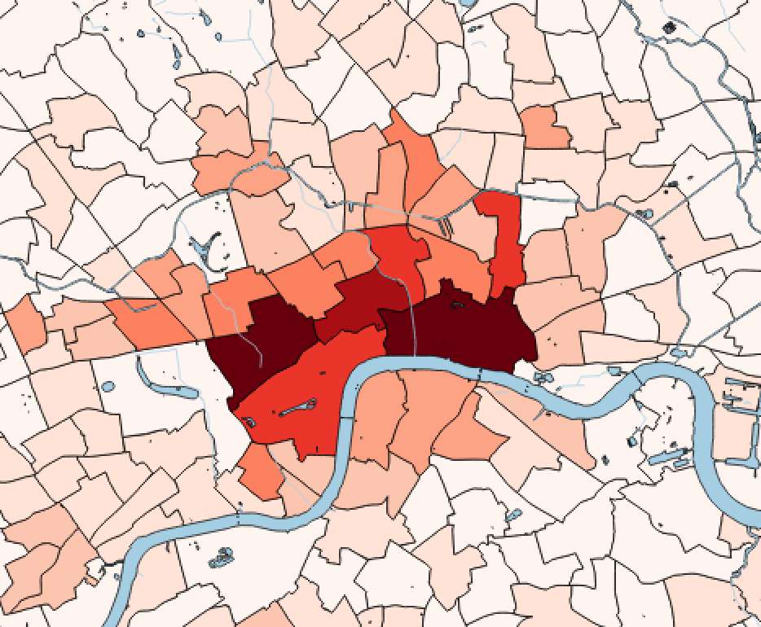

What do we learn: The West End, in Westminster, has 135 pubs covering 199 hectares for a density of 675 per 1,000. The East End, on the other hand, has 209 pubs, but in 315 hectares, for a density of 664.